Option #2: Build a Pytorch Demo

Edmond Tucker
Colorado State University Global
CSC525: Principles of Machine Learning
Dong Nguyen, Dr.
14 April 2024

Option #2: Build a Pytorch Demo
Understanding how PyTorch is integrated with building natural language processing NLP models and the complexities associated with its adaptability in modern deep learning frameworks, offers an inducing glimpse into the competence of such models. Through this project, I explored the nuances of installing PyTorch, implementing various model architectures, and fine-tuning parameters to enhance text generation capabilities using the text from "Moby Dick" by Herman Melville (Moby Dick; or, the Whale by Herman Melville, 2021).
Installation of PyTorch
The installation of PyTorch was straightforward and simple considering my machine already had Python, pip, and torch installed. Utilizing the GPU acceleration via--cuda, the machine already had an updated CUDA version installed and was critical in training the deep learning model. The only requirement necessary for building this PyTorch demo was downloading the GitHub repository for the chosen example, world_language_model (PyTorch Examples, 2022).
Model Implementation: The World Language Model
The "World Language Model" example from PyTorch's GitHub repository was used for this demonstration of the process in language model training to predict words utilizing the literary style of “Moby Dick” (Why GitHub?, 2021). Multiple instances of the example were executed to train four different models which generated four variations of predicted text.
Comparative Analysis of Model Architectures
In exploring the effectiveness of various architectures, I tested four different models: GRU, LSTM, RNN_RELU, and Transformer. Each model was adjusted with specific parameters to evaluate performance under different configurations:
- GRU: Achieved a test perplexity of 915.55, indicating moderate efficiency in language modeling.
- LSTM: Showed the best performance with a perplexity of 804.41, likely due to its strength in capturing longer dependencies within the text.
- RNN_RELU: Had the highest perplexity at 2872.94, struggling with the complexity of the task, possibly due to inherent limitations in handling long-range dependencies.
- Transformer: Recorded a perplexity of 1581.94, underperforming in this scenario despite its usual proficiency in NLP tasks, suggesting potential needs for further parameter tuning.
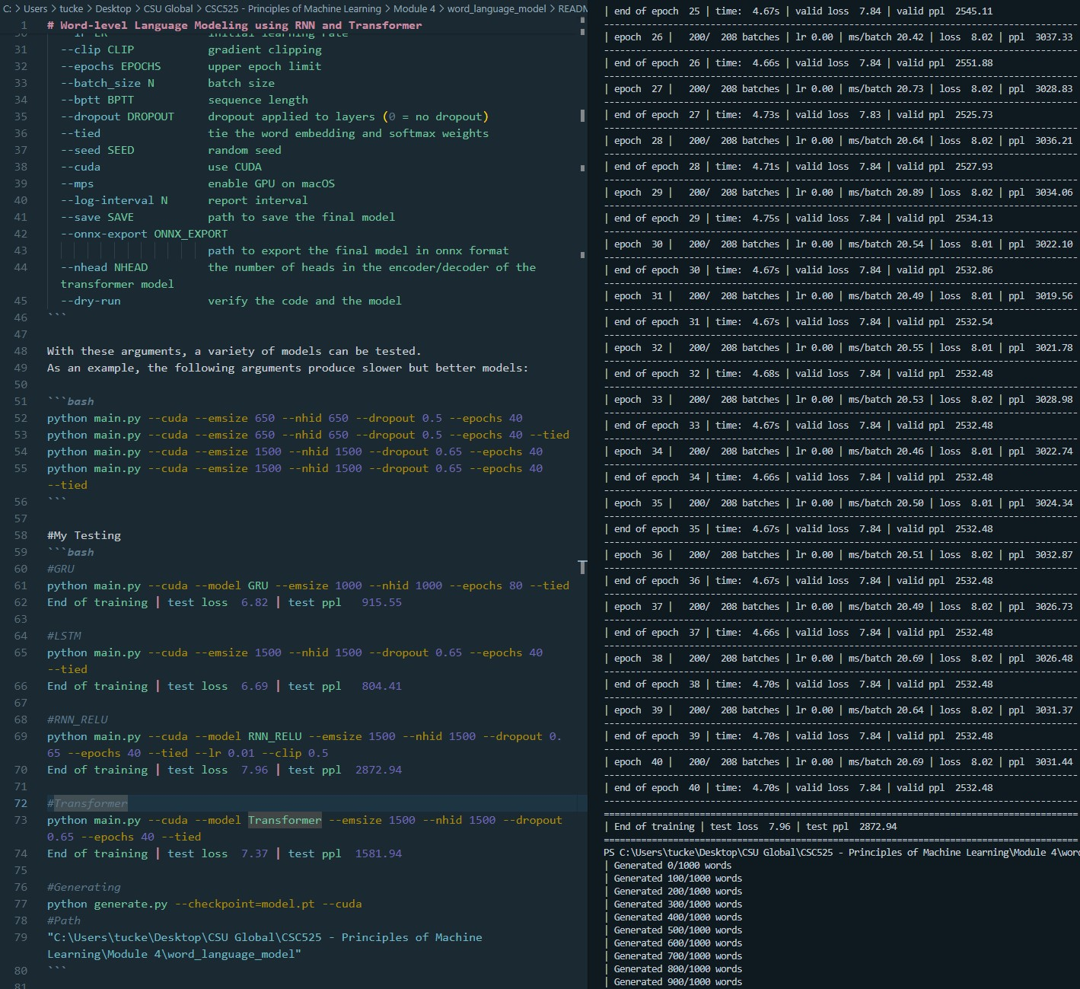
Potential Improvements and Applications
The data used, primarily the text from "Moby Dick", could be diversified to enhance the model's robustness and generalization capabilities. Integrating texts from various genres or authors could provide a broader linguistic exposure, improving the model's ability to generate more creative and varied text outputs. Additionally, techniques such as dropout and gradient clipping used in these experiments are valuable for combating overfitting and stabilizing training across different model architectures.
Portfolio Project
The techniques gained from PyTorch examples can be leveraged to help train the chatbot models for the portfolio project. They would help with the natural language responses to the user by predicting human sentence structure and phraseology.
Conclusion
This project not only enhanced my practical skills in using PyTorch and training deep learning models but also provided valuable insights into the strategic choices behind model configurations and how they could be used in the final portfolio project. The LSTM and Transformer models, despite their different outcomes in this experiment, remain powerful tools for NLP tasks, with their effectiveness highly contingent on the specific setup and application. Further research and experimentation could uncover more about optimizing these models for various tasks, as evidenced by ongoing studies and developments in the field (Vaswani et al., 2017; Pascanu et al., 2017).

References
Why GitHub? (2021). Pytorch / examples. https://github.com/pytorch/examples/
PyTorch Examples. (2022). PyTorch. https://pytorch.org/examples/
Moby Dick; or, The Whale by Herman Melville. (2021, August 18). Project Gutenberg. https://www.gutenberg.org/ebooks/2701
Vaswani, A., Shazeer, N., Parmar, N., Uszkoreit, J., Jones, L., Gomez, A. N., ... & Polosukhin, I. (2017). Attention is all you need. In Advances in neural information processing systems (pp. 5998-6008).

